**GIT and GITHUB 02 TASKS**

1)Install git.

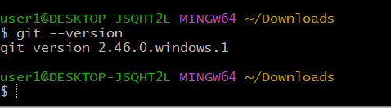

2)Create a repo in github with README.md and .ignore file.

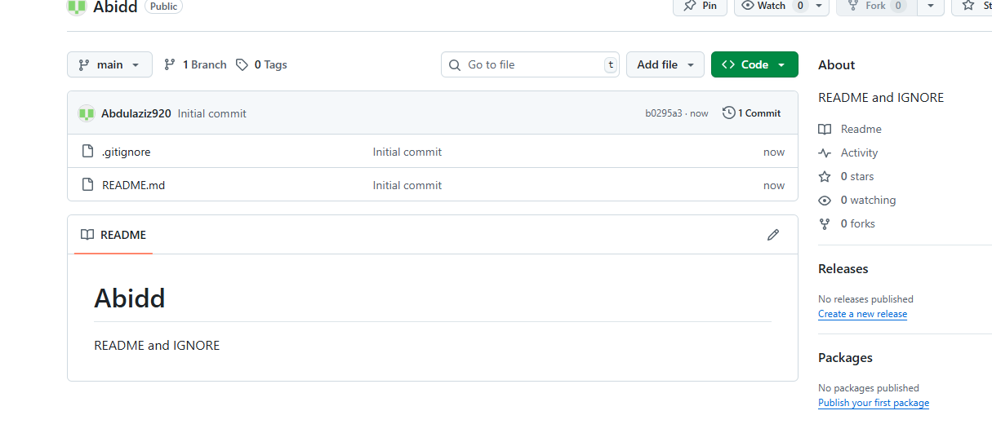

3)Clone the created repo to local.

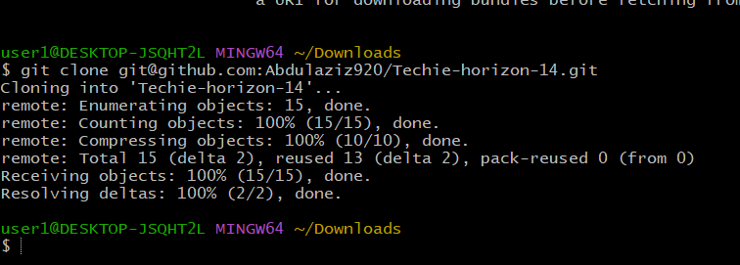

4)Create two files in local repo.

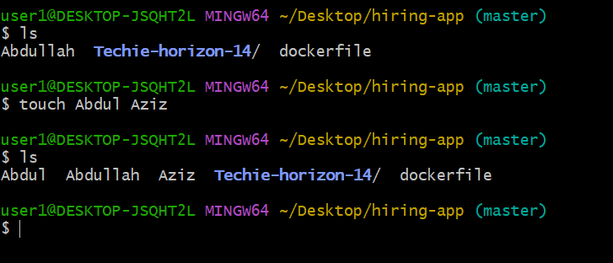

5)Commit two files and push to central Repository.

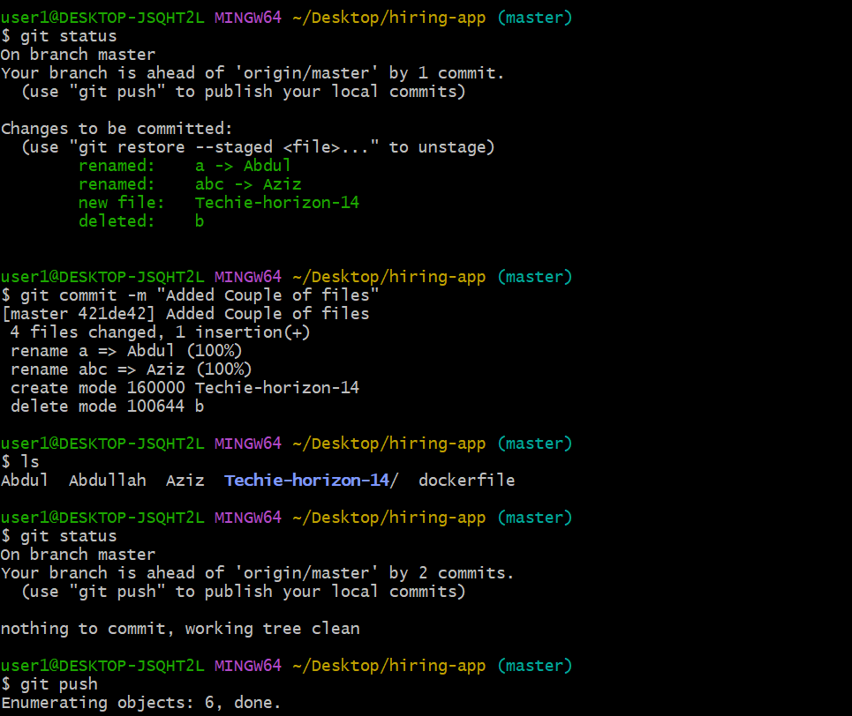

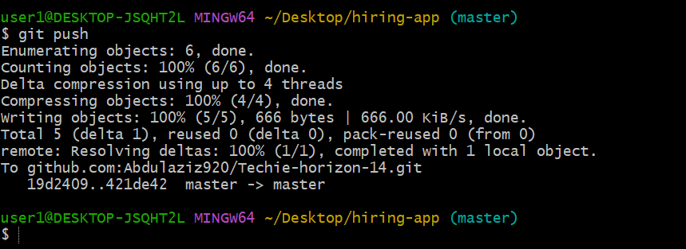

6)Create a branch in local and create a sample file and push to central.

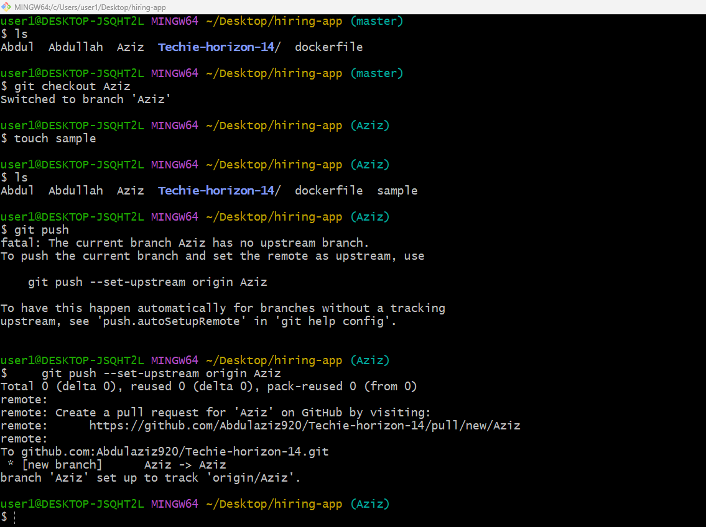

7)Create a branch in github and clone that to local.

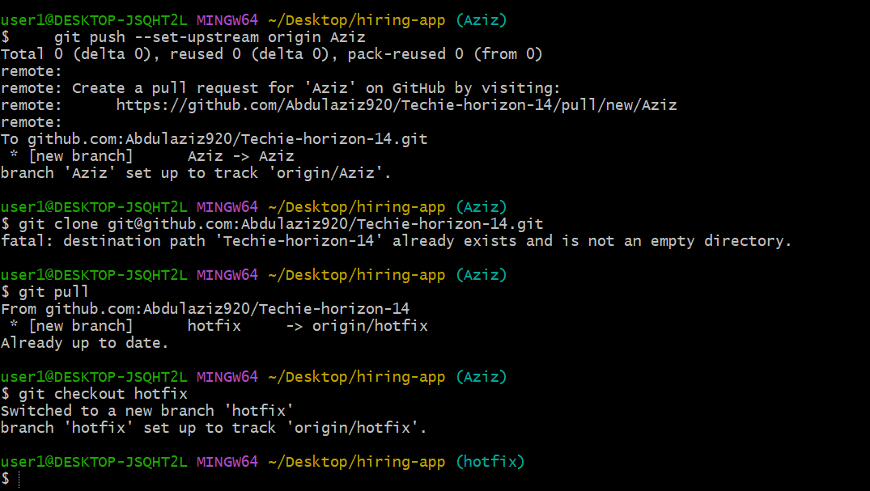

8)Merge the created branch with master in git local.

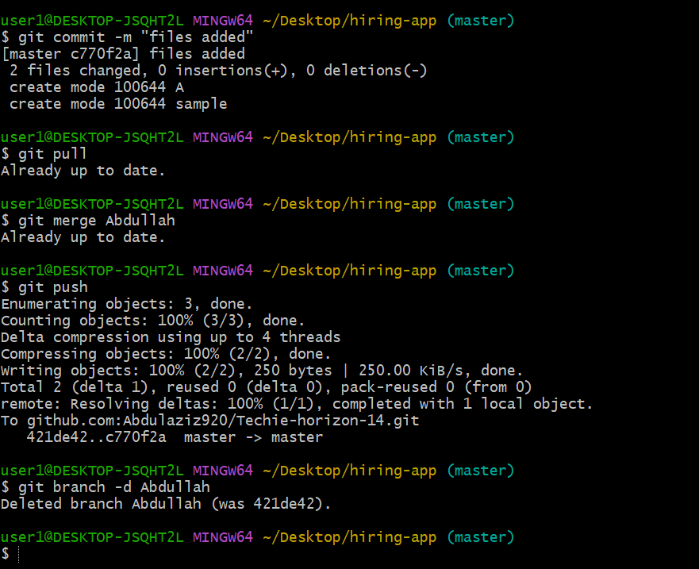

9)Merge the created branch with master in github by sending a pull request.

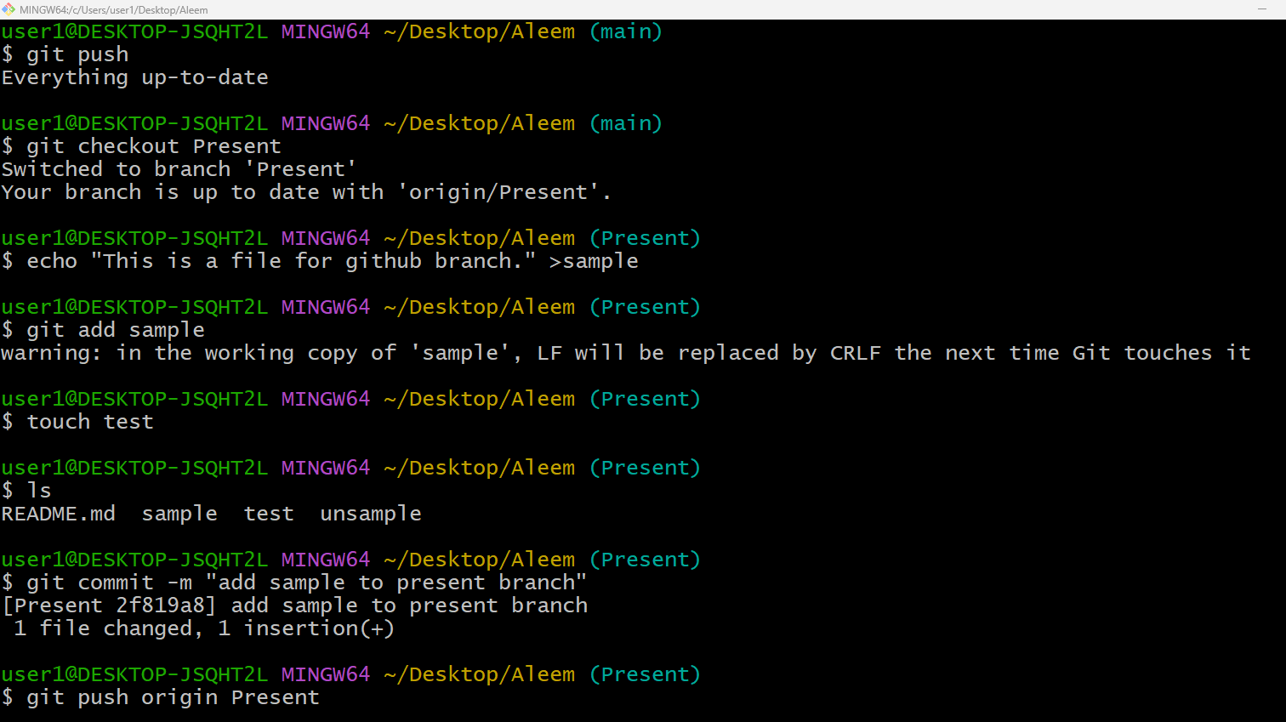

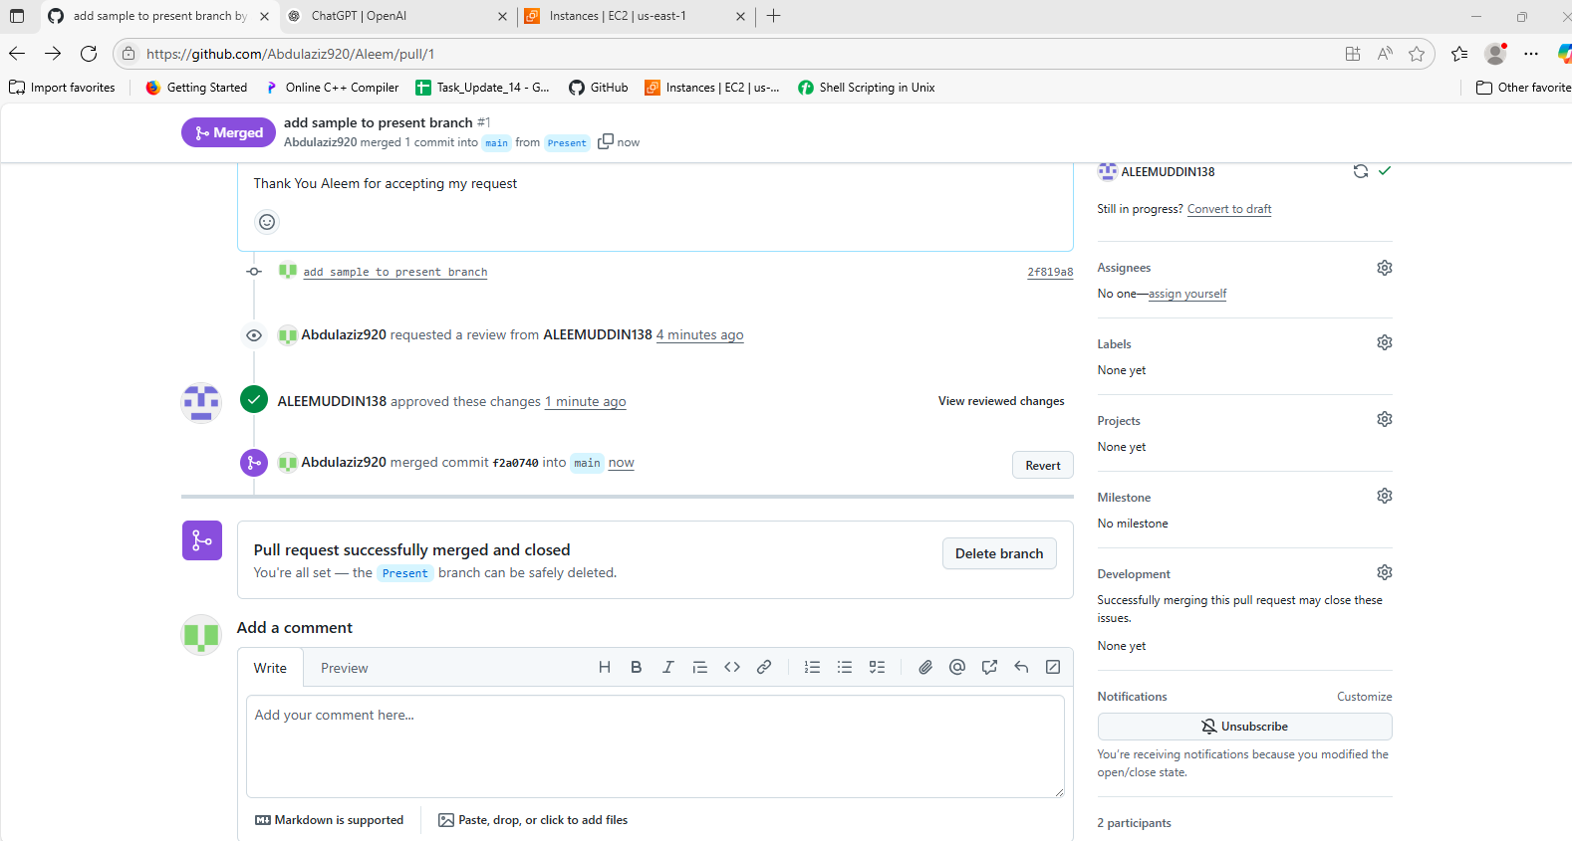

10)create a file in local and send that to branch in github.

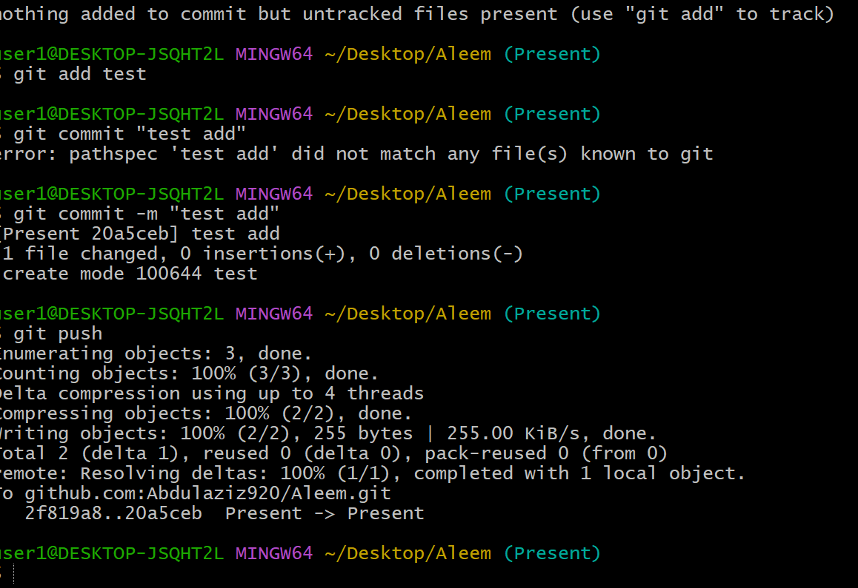

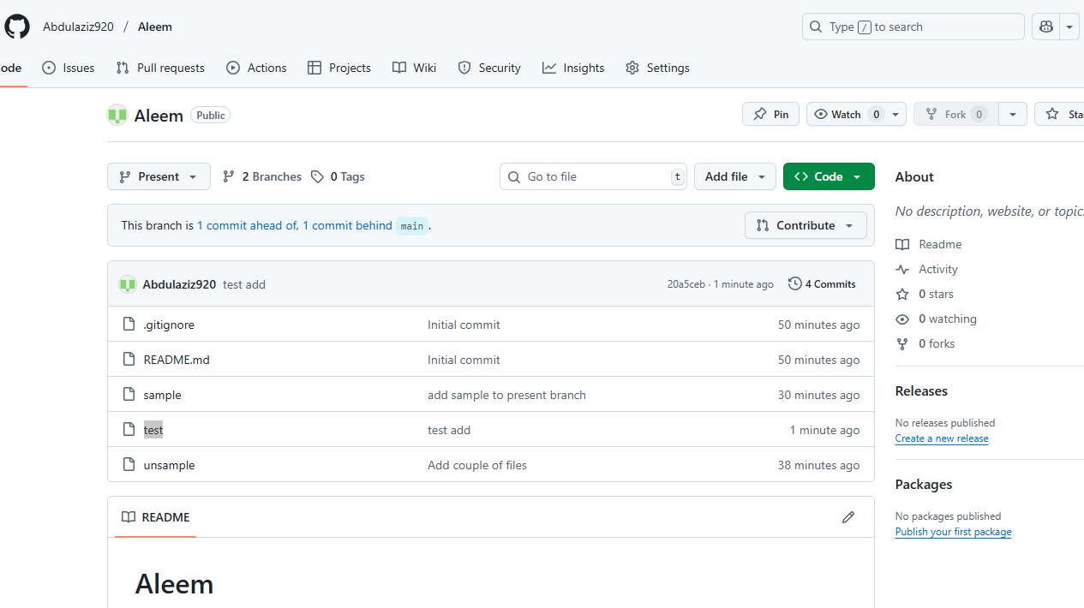

11)clone only a branch from github to local.

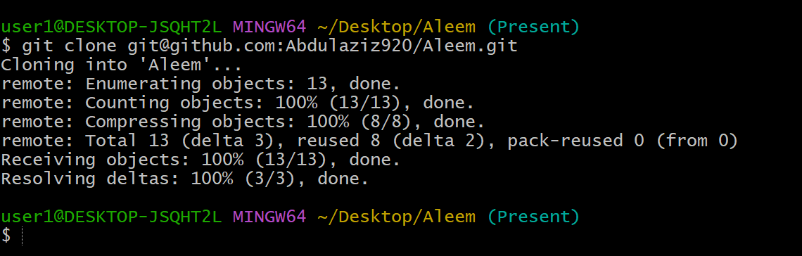

12)create a file with all passwords and make that untrackable with git.

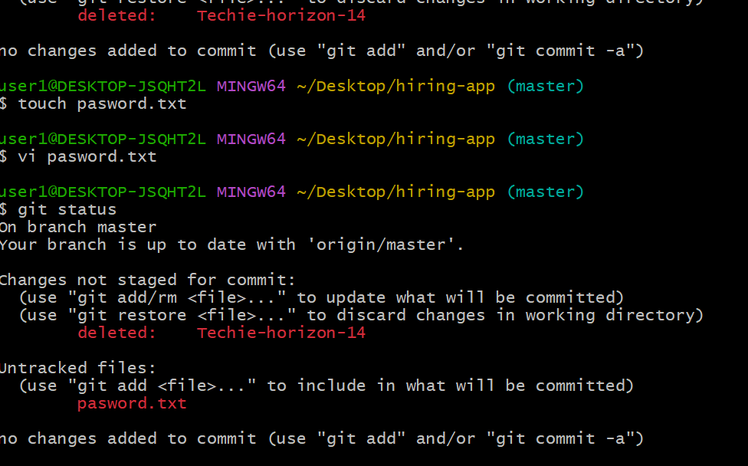

13)make a commit and make that commit reset without savings changes.

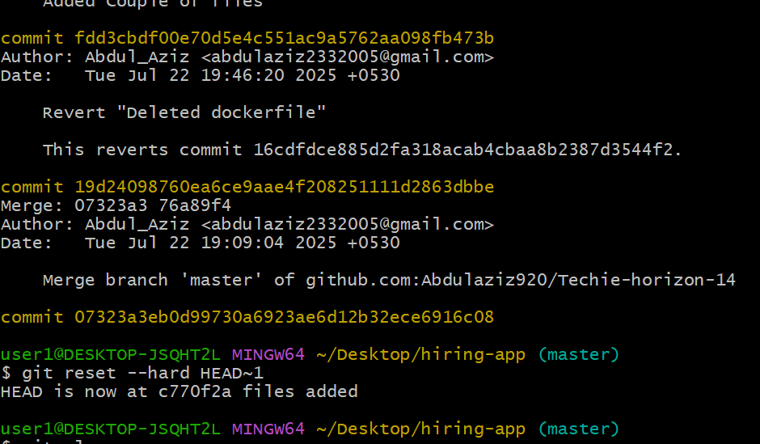

14)Revert a commited commit to the older version.

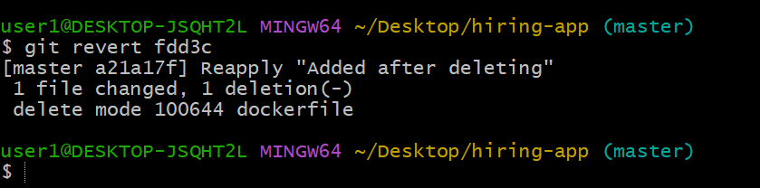

15)push a file to stash without savings the changes and work on another file.

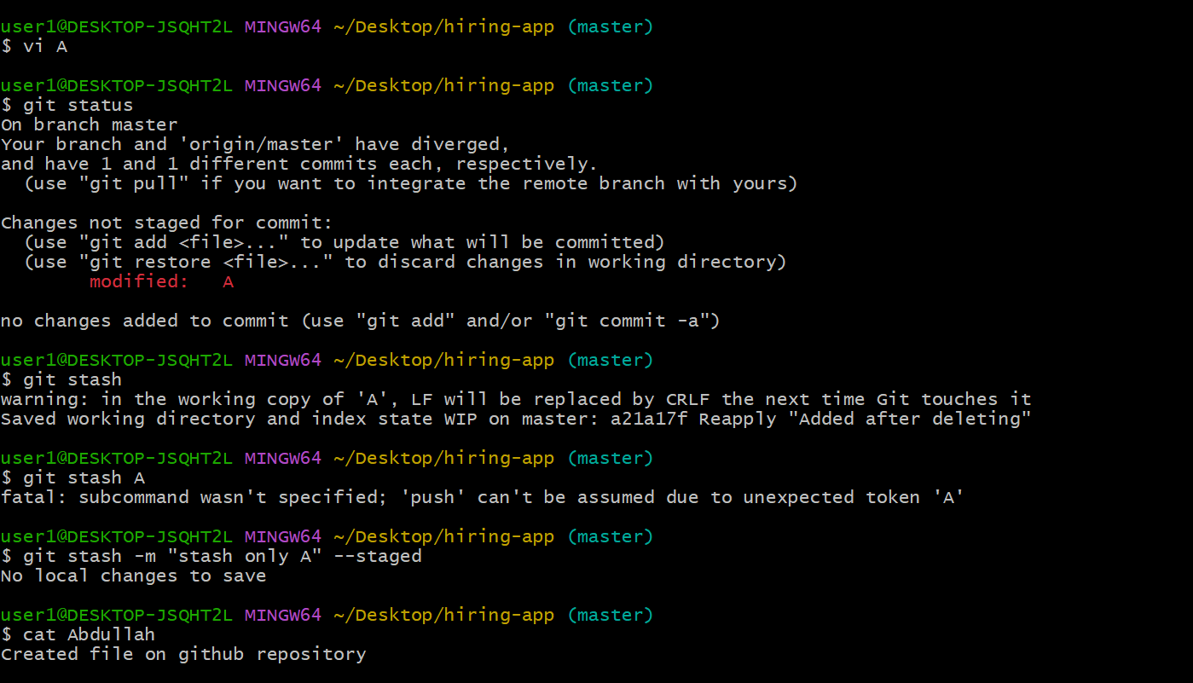

16)undo the stash file and start working on that again.

17)generate a ssh-keygen and configure into github.

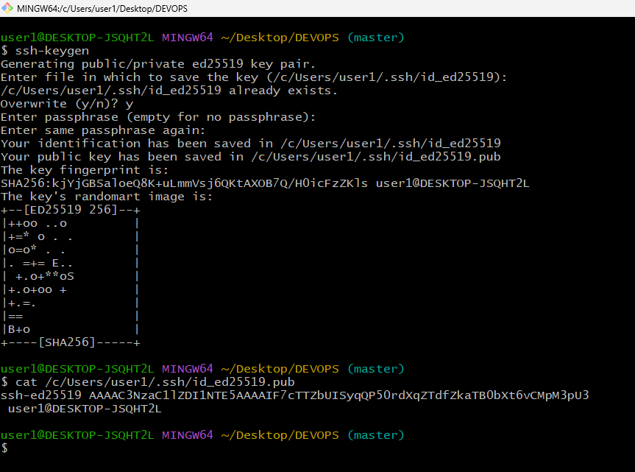

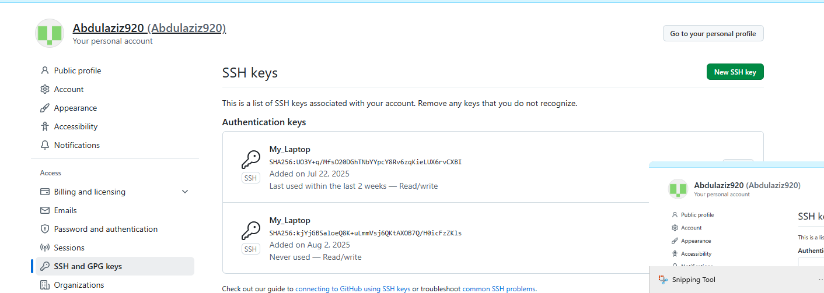

18)configure webhooks to github.

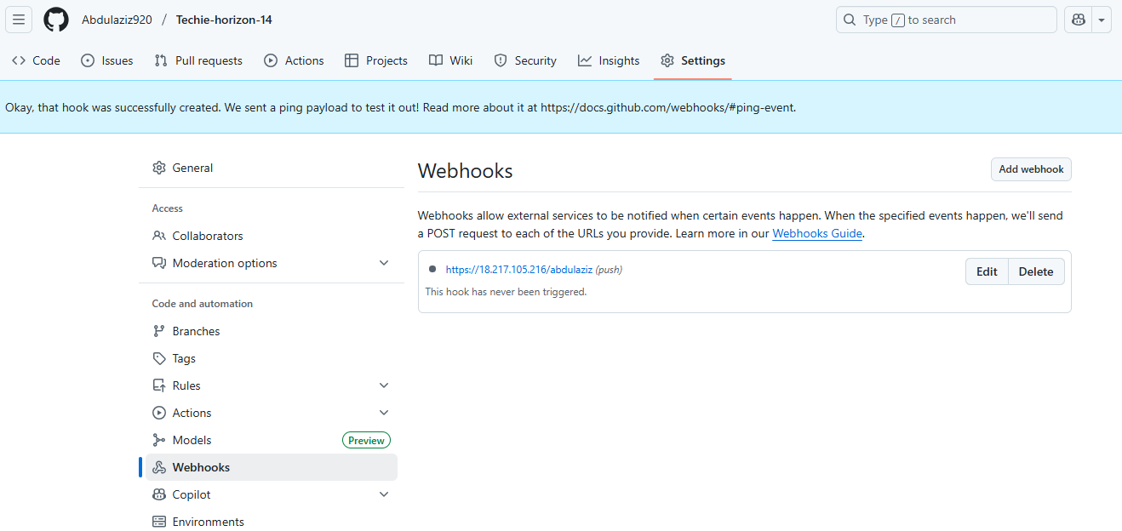

19)basic understanding of .git file.

A: Git creates a hidden .git/ folder inside your project. This folder   
contains everything Git needs to track changes, branches,   
history, remotes, and more.

20)Check all the logs of git.

A: git log  
git log --oneline # One-line per   
commit  
git log --graph # Shows branches   
and merges  
git log --all # Shows commits from  
all branches  
git log --stat # Shows file-level   
changes in each commit

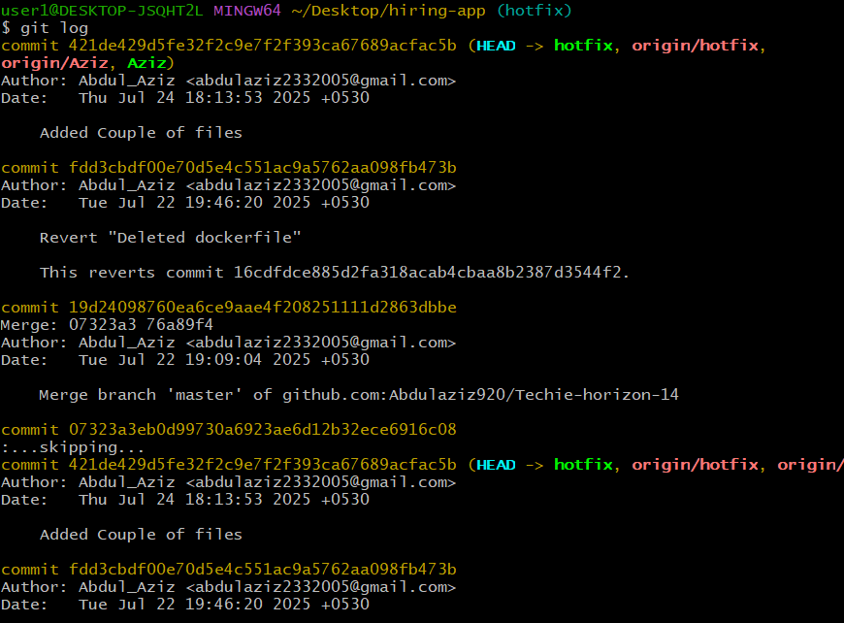

21)Rename the commit message.

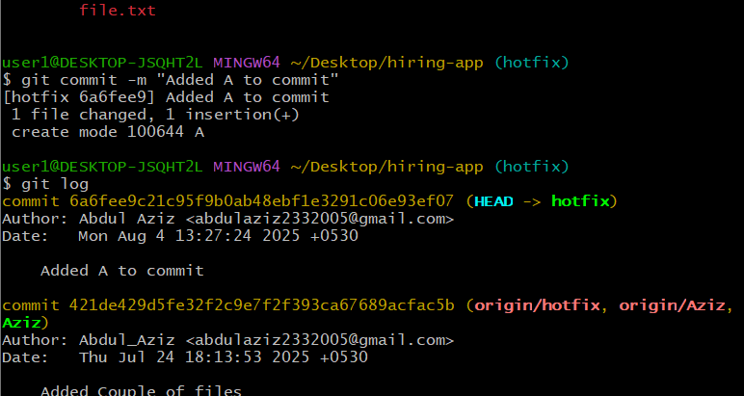

22)Merge multiple commits into single commit.

